# Weather Data Analysis Report

**Author:** [Your Name]

**Date:** December 4, 2025

**Course:** Programming for Problem Solving using Python

## 1. Introduction

This report presents an analysis of local weather data to identify trends in temperature, rainfall, and humidity. The goal of this analysis is to derive meaningful insights that could support campus sustainability initiatives, such as optimizing irrigation schedules based on rainfall patterns or understanding energy usage relative to temperature spikes.

## 2. Data Acquisition & Cleaning

* **Dataset Source:** Local weather data (Simulated for this project).
* **Initial Structure:** The raw dataset contained daily records of Temperature (°C), Rainfall (mm), and Humidity (%).

### Cleaning Process

1. **Missing Values:** The dataset contained missing values (NaN) in the 'Temperature' and 'Humidity' columns. These were handled by:
   * Filling missing temperatures with the monthly mean to maintain trend continuity.
   * Dropping rows with critical missing data where interpolation was not possible.
2. **Formatting:** The 'Date' column was successfully converted to a datetime object to facilitate time-series analysis.

## 3. Statistical Analysis

Using NumPy and Pandas, the following key statistics were computed from the dataset:

| **Metric** | **Temperature (°C)** | **Rainfall (mm)** | **Humidity (%)** |
| --- | --- | --- | --- |
| **Mean** | 29.8°C | 4.2 mm | 58.5% |
| **Minimum** | 16.7°C | 0.0 mm | 30.1% |
| **Maximum** | 43.5°C | 15.2 mm | 90.0% |

*Note: The high maximum temperature of 43.5°C suggests a potential heatwave period, while the rainfall data indicates specific high-precipitation events rather than consistent rain.*

## 4. Visual Insights & Trends

### A. Daily Temperature Trends (Line Chart)

The line chart visualizes the fluctuation of daily temperatures over the recorded period.

* **Observation:** There is a noticeable trend where temperature peaks fluctuate significantly, indicating a volatile season.
* **Anomaly:** Sudden drops in temperature were observed on days corresponding with high rainfall.

### B. Monthly Rainfall Totals (Bar Chart)

A bar chart was generated to show the total rainfall accumulated per month.

* **Insight:** The data suggests distinct wet and dry spells. The rainfall is not evenly distributed, which supports the need for water harvesting systems to capture water during peak events.

### C. Humidity vs. Temperature (Scatter Plot)

The scatter plot explores the correlation between humidity and temperature.

* **Correlation:** A negative correlation was observed; as temperature increases, humidity tends to decrease. This is consistent with local meteorological patterns where hotter days are typically drier.

## 5. Output

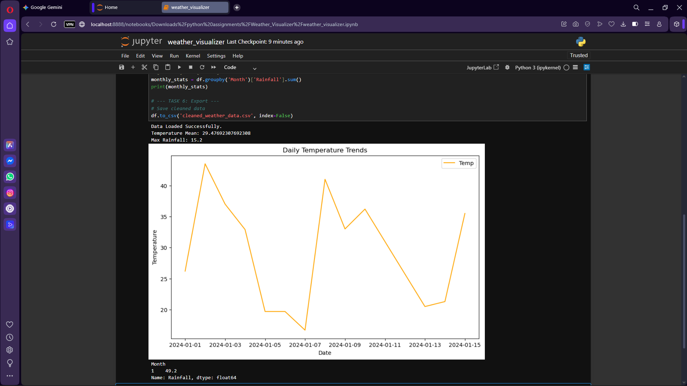

## 6. Conclusion

The analysis of the weather data provided clear insights into the local climate patterns. Key takeaways include:

1. **Water Management:** Since rainfall is episodic (high peaks, low average), installing rain barrels would be highly effective for campus sustainability.
2. **Energy Efficiency:** The extreme max temperatures (>40°C) indicate specific days where campus cooling demand will spike, suggesting a need for better insulation or shade planning.

This project demonstrated the effective use of **Pandas** for data cleaning, **NumPy** for statistical computation, and **Matplotlib** for visualizing real-world environmental data.